SparkNotes
SearchMenu

Macbeth
Read the Translation
- Recommend this on Facebook
- Share on Tumblr
- Share on Twitter

Themes
Themes are the fundamental and often universal ideas explored in a literary work.

The Corrupting Power of Unchecked Ambition
The main theme of Macbeth—the destruction wrought when ambition goes unchecked by moral constraints—finds its most powerful expression in the play’s two main characters. Macbeth is a courageous Scottish general who is not naturally inclined to commit evil deeds, yet he deeply desires power and advancement. He kills Duncan against his better judgment and afterward stews in guilt and paranoia. Toward the end of the play he descends into a kind of frantic, boastful madness. Lady Macbeth, on the other hand, pursues her goals with greater determination, yet she is less capable of withstanding the repercussions of her immoral acts. One of Shakespeare’s most forcefully drawn female characters, she spurs her husband mercilessly to kill Duncan and urges him to be strong in the murder’s aftermath, but she is eventually driven to distraction by the effect of Macbeth’s repeated bloodshed on her conscience. In each case, ambition—helped, of course, by the malign prophecies of the witches—is what drives the couple to ever more terrible atrocities. The problem, the play suggests, is that once one decides to use violence to further one’s quest for power, it is difficult to stop. There are always potential threats to the throne—Banquo, Fleance, Macduff—and it is always tempting to use violent means to dispose of them.

The Relationship Between Cruelty and Masculinity
Characters in Macbeth frequently dwell on issues of gender. Lady Macbeth manipulates her husband by questioning his manhood, wishes that she herself could be “unsexed,” and does not contradict Macbeth when he says that a woman like her should give birth only to boys. In the same manner that Lady Macbeth goads her husband on to murder, Macbeth provokes the murderers he hires to kill Banquo by questioning their manhood. Such acts show that both Macbeth and Lady Macbeth equate masculinity with naked aggression, and whenever they converse about manhood, violence soon follows. Their understanding of manhood allows the political order depicted in the play to descend into chaos.
At the same time, however, the audience cannot help noticing that women are also sources of violence and evil. The witches’ prophecies spark Macbeth’s ambitions and then encourage his violent behavior; Lady Macbeth provides the brains and the will behind her husband’s plotting; and the only divine being to appear is Hecate, the goddess of witchcraft. Arguably, Macbeth traces the root of chaos and evil to women, which has led some critics to argue that this is Shakespeare’s most misogynistic play. While the male characters are just as violent and prone to evil as the women, the aggression of the female characters is more striking because it goes against prevailing expectations of how women ought to behave. Lady Macbeth’s behavior certainly shows that women can be as ambitious and cruel as men. Whether because of the constraints of her society or because she is not fearless enough to kill, Lady Macbeth relies on deception and manipulation rather than violence to achieve her ends.
Ultimately, the play does put forth a revised and less destructive definition of manhood. In the scene where Macduff learns of the murders of his wife and child, Malcolm consoles him by encouraging him to take the news in “manly” fashion, by seeking revenge upon Macbeth. Macduff shows the young heir apparent that he has a mistaken understanding of masculinity. To Malcolm’s suggestion, “Dispute it like a man,” Macduff replies, “I shall do so. But I must also feel it as a man” (4.3.221–223). At the end of the play, Siward receives news of his son’s death rather complacently. Malcolm responds: “He’s worth more sorrow [than you have expressed] / And that I’ll spend for him” (5.11.16–17). Malcolm’s comment shows that he has learned the lesson Macduff gave him on the sentient nature of true masculinity. It also suggests that, with Malcolm’s coronation, order will be restored to the Kingdom of Scotland.

The Difference Between Kingship and Tyranny
In the play, Duncan is always referred to as a “king,” while Macbeth soon becomes known as the “tyrant.” The difference between the two types of rulers seems to be expressed in a conversation that occurs in Act 4, scene 3, when Macduff meets Malcolm in England. In order to test Macduff’s loyalty to Scotland, Malcolm pretends that he would make an even worse king than Macbeth. He tells Macduff of his reproachable qualities—among them a thirst for personal power and a violent temperament, both of which seem to characterize Macbeth perfectly. On the other hand, Malcolm says, “The king-becoming graces / [are] justice, verity, temp’rance, stableness, / Bounty, perseverance, mercy, [and] lowliness” (4.3.92–93). The model king, then, offers the kingdom an embodiment of order and justice, but also comfort and affection. Under him, subjects are rewarded according to their merits, as when Duncan makes Macbeth thane of Cawdor after Macbeth’s victory over the invaders. Most important, the king must be loyal to Scotland above his own interests. Macbeth, by contrast, brings only chaos to Scotland—symbolized in the bad weather and bizarre supernatural events—and offers no real justice, only a habit of capriciously murdering those he sees as a threat. As the embodiment of tyranny, he must be overcome by Malcolm so that Scotland can have a true king once more.
More main ideas from Macbeth
- Motifs
- Symbols

Got it?
Take a quiz on this section →

Motifs
Next

Take a Study Break
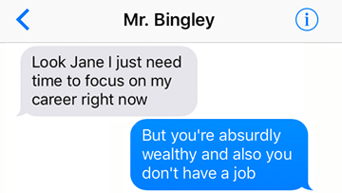

How fictional characters would break up with you over text
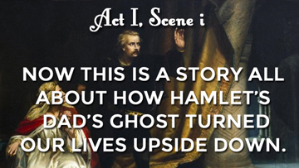

Every single scene of Hamlet summed up in 1 sentence
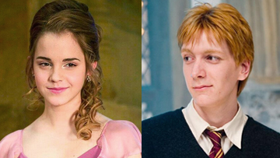

Harry Potter characters that would've made WAY better couples
- Apps
- Contact
- Legal
- Facebook
- Tumblr
- Twitter
© 2017 SparkNotes LLC, All Rights Reserved
View Full Site
✖

